Akole Taluka Education Society’s
Agasti Arts, Commerce and Dadasaheb Rupwate Science College, Akole
Tal Akole Dist Ahmednagr
Board of Student’s Development
विद्यार्थी विकास मंडळ
Activities

Conducted Activities - Day’s Celebrated
College Students and Staff Celebrating Rashtrapita Mahatma Gandhi and Lal Bahadur Shastri Jayanti in college (Date : 02nd Oct 2017)
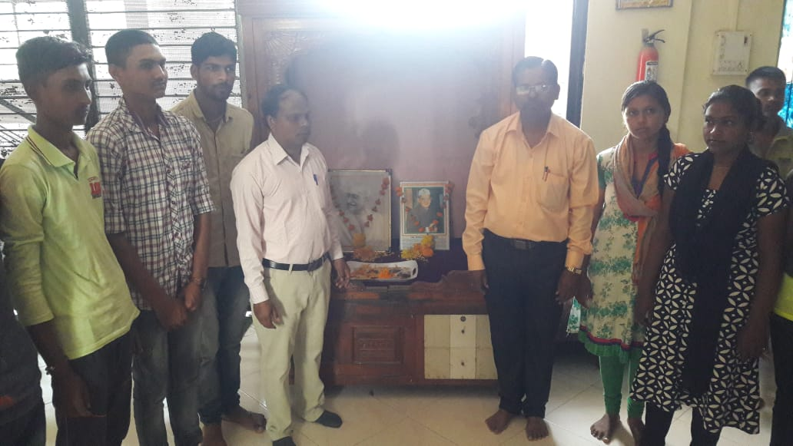 | 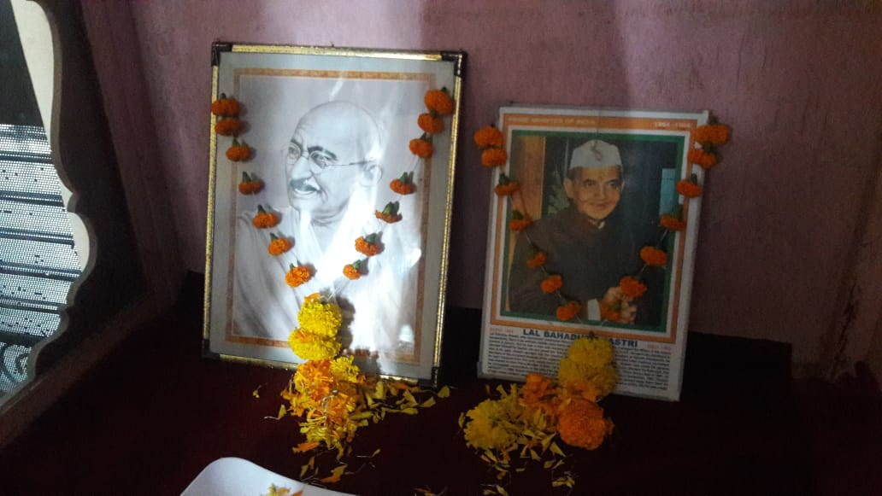

Vachan Prerna Din - Dr. APJ Abdul Kalam Birth Anniversary
Date : 15th Oct. 2017
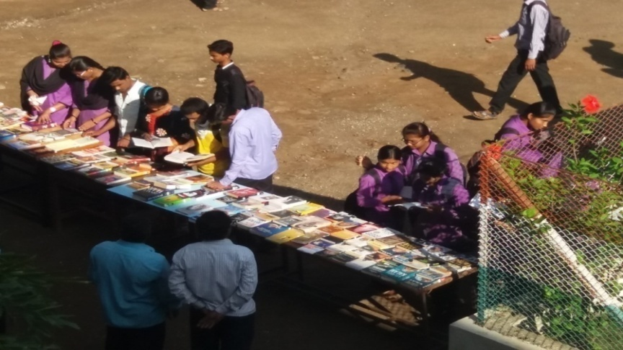 | 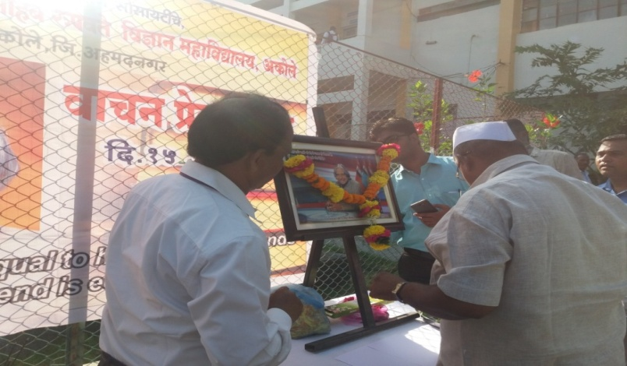
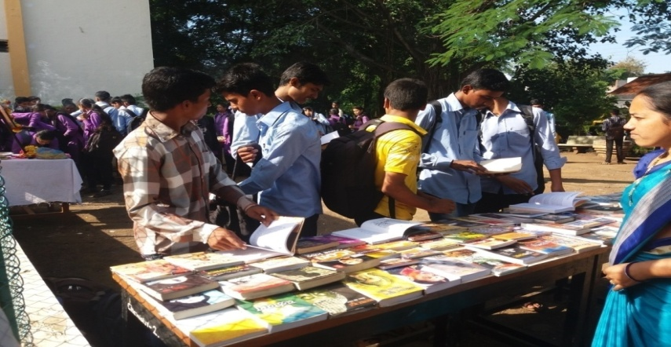 | 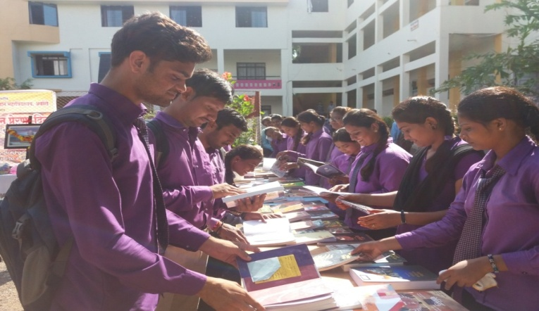

Various Activities Conducted in College
Day’s Celebrated
Students Making Plastic Free Campus  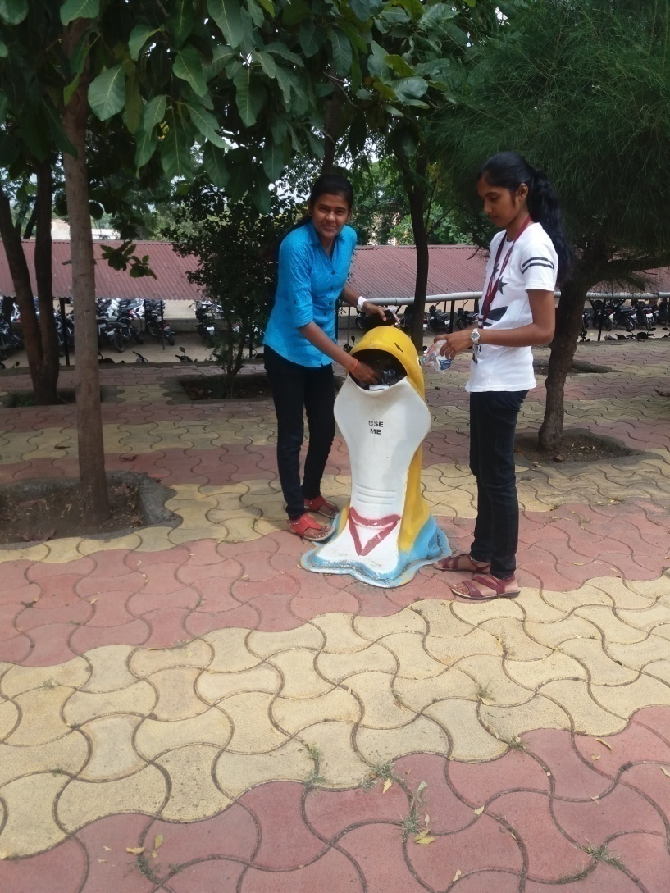 | Tree Plantation by teaching Staff and Students of College  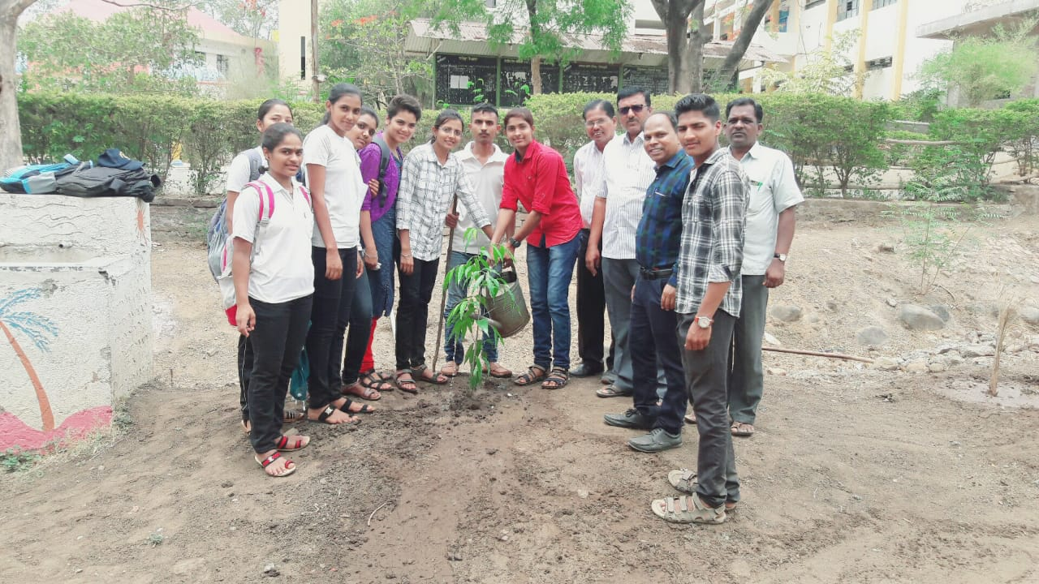

College Staff Participating in Yoga Day on college ground : Date 21st June 2018
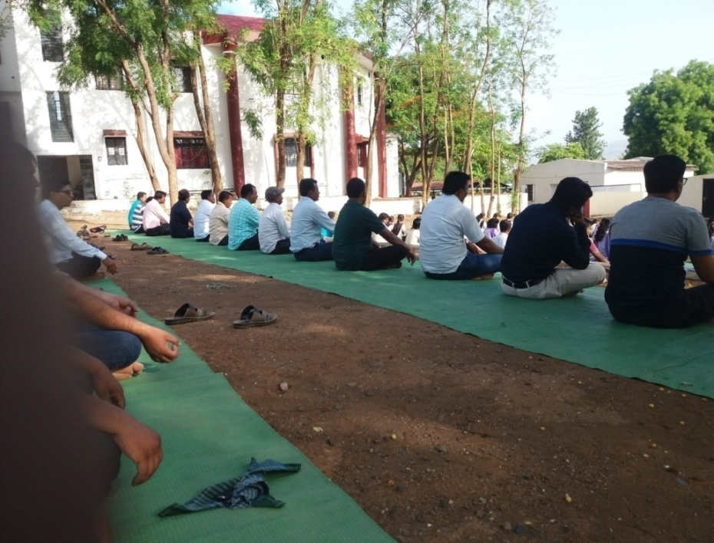 | 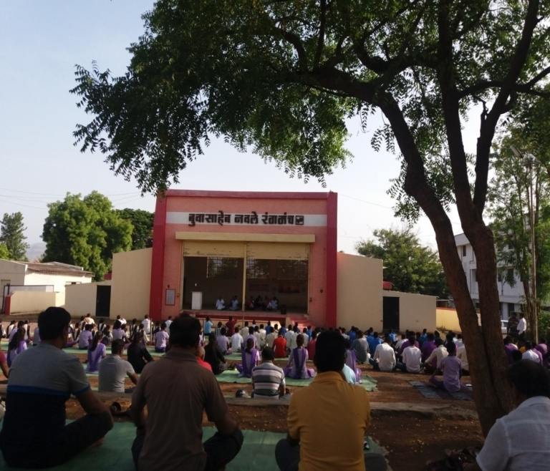

Voter Day
Date : 15th March 2019

Principal Dr. Bhaskar Shelke and Government Authorities Addressing Students  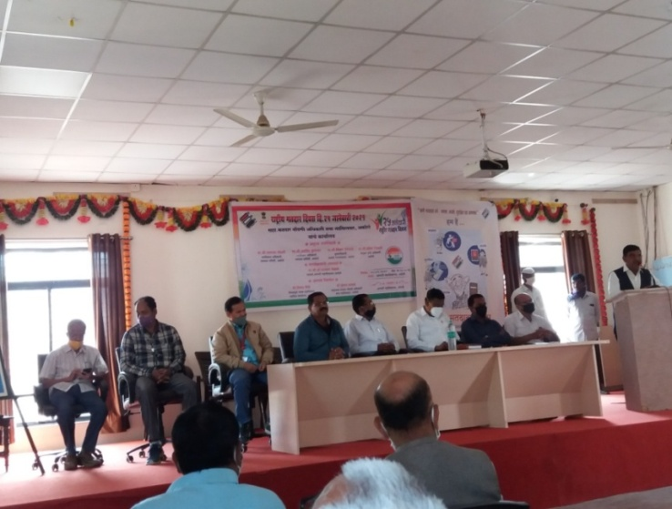 | College Students Drawing  Rangoil regarding awarness of Voters day  