Akole Taluka Education Society’s
Agasti Arts, Commerce and Dadasaheb Rupwate Science College, Akole
Tal Akole Dist Ahmednagr
Board of Student’s Development
विद्यार्थी विकास मंडळ
Activities

World Disability Day Date : 03rd Dec. 2021
Disabled Student of Our College

Ghane Vanita  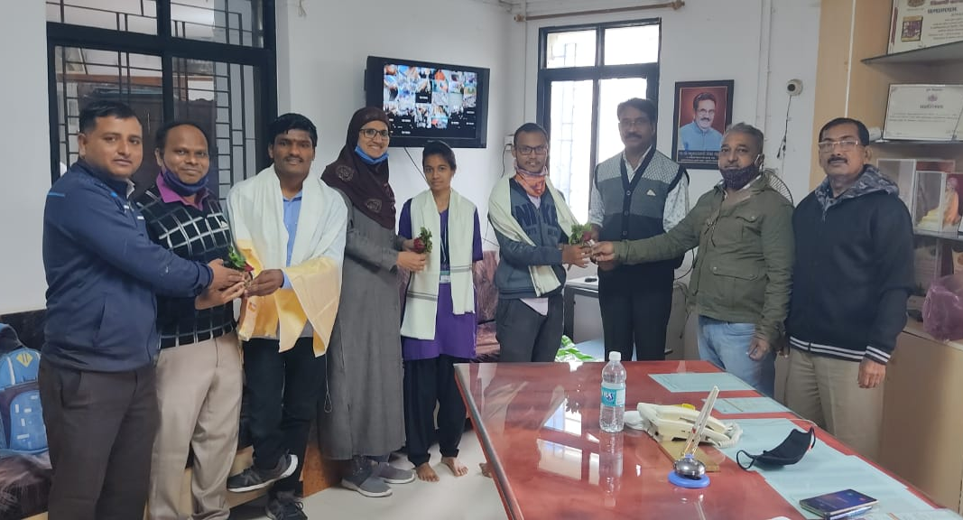 | Gaikwad Rutvik  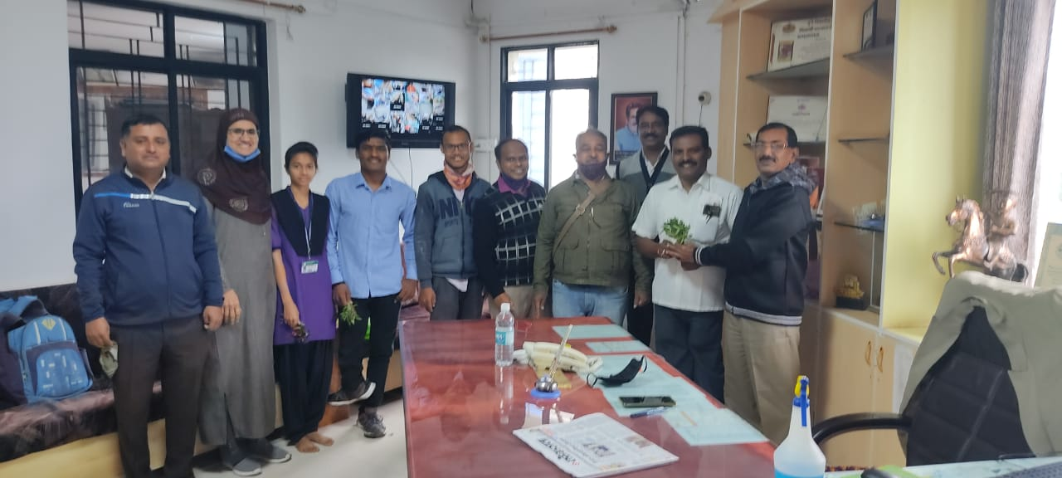

Marathi Bhasha Gaurav Din (Online)
Date : 27th Feb 2022
Resource Person - 1. Dr. Baburao Upadhye  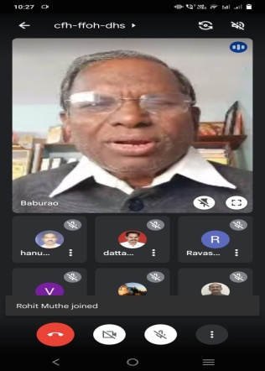 | Resource Person Dr. Dattatray Gandhare  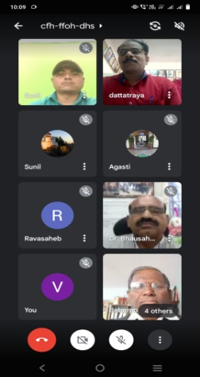
Resource Person: Dr. Raosaheb Nannaware
