साहसे श्री प्रतिवसति |

Akole Taluka Education Society

Agasti Arts, Commerce and Dadasaheb Rupwate Science College Akole

**Department of Economics**

Activates

Activates 1

**State Level Seminar Arrange by Department**

**Topic - Agriculture Problems and Prospects in Maharashtra**

**Sponsored by - Savitribai Phule Pune University, Pune**

Brochure

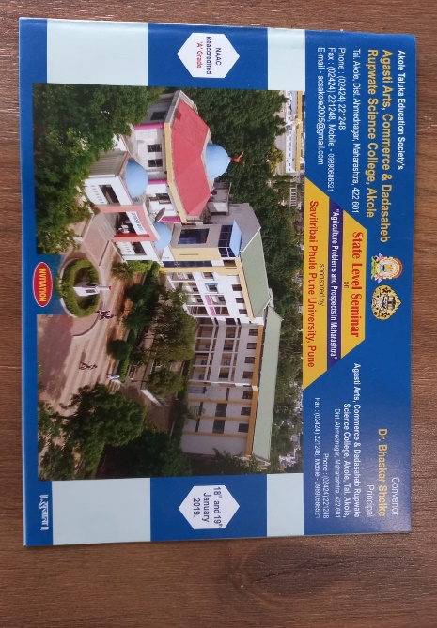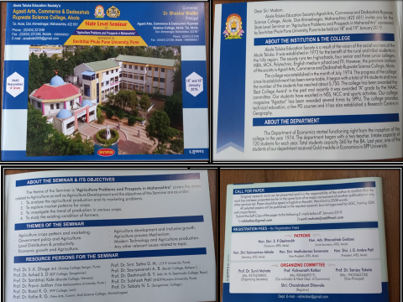

**Seminar Journals**

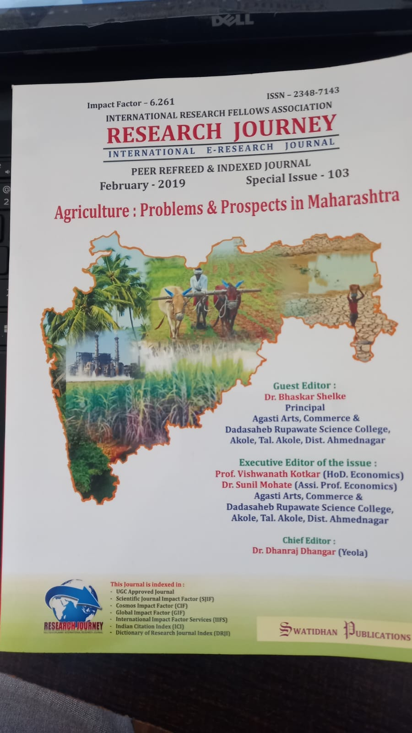

**Resource Person Photos**

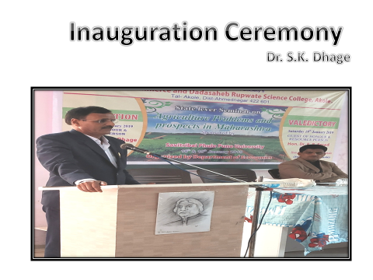 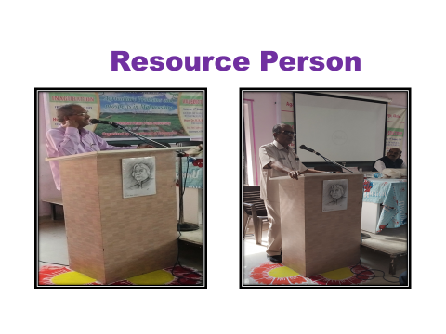

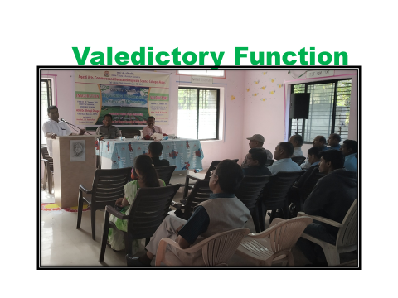

Activates 1

Students visited in patsantha

