**Principal - Dr. Bhaskar Trimbak Shelke**

       Rotary CLUB Akole

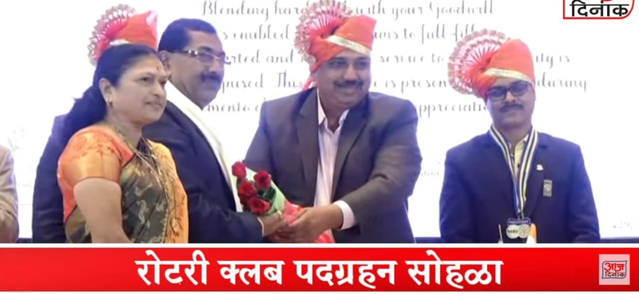

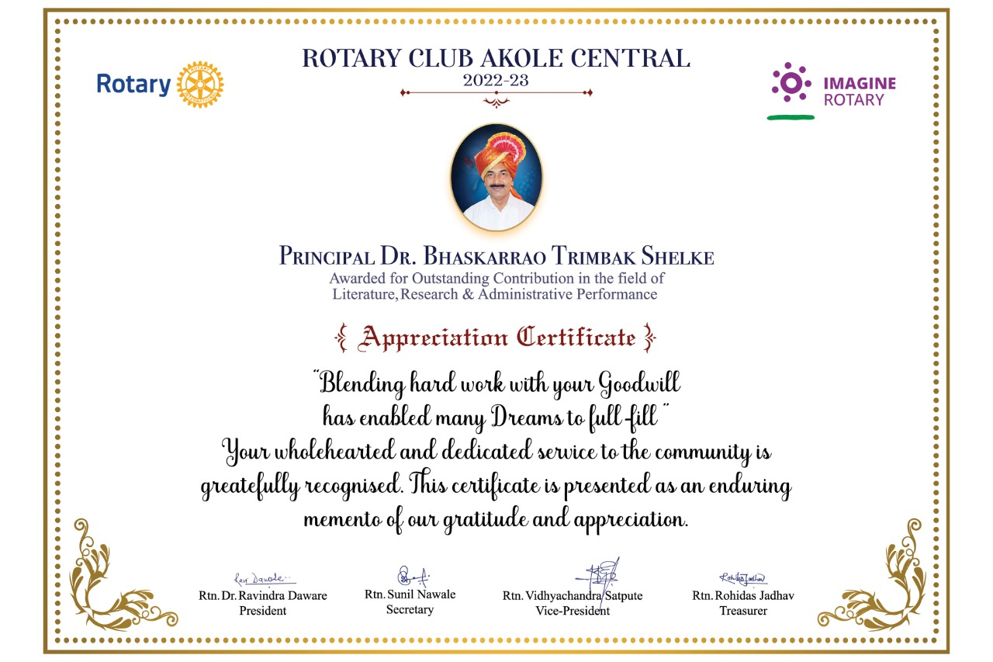

**Dr. Sunil Ganpat Ghankuate**

**Mharashtratil adivshi dubla jamatiche loksahity ya pustakas dr. govind Gare puraskar,**

**&**

**Akhil Bharatiy Adivashi dubla Samajachya vatine denyat yenara Adarshy Shikshak Puraskae**

