Department of Chemistry
Awards

1) Dr. Sanjay Takate :

“Best Teacher Award 2019-20” by Rotary Club, Akole

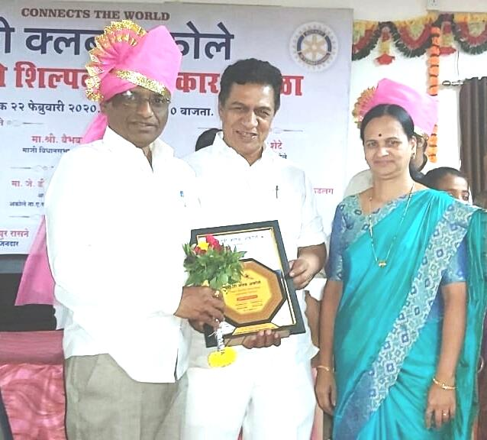

2) Prof. Sandesh Kasar :

“Best District Coordinator 2021-22”

By Career Katta, An initiative by Higher & Technical Education Department, Maharashtra Government & Maharashtra Information Technology Support Centre (MITSC)
