Akole Taluka Education Society’s
Agasti Arts,Commerce and Dadasaheb Rupwate Science College Akole
Tal-Akole Dist-Ahmednagar
Botany Department Activities

Events and Activity (03)
Sr. No. | Title of Activity | Date
1. | Workshop Organised on Mushroom Cultivation for the Students funded by Board of Students Development, Savitribai Phule Pune University, Pune, Maharashtra. | 24/02/2020
2. | ‘Avishkar’ Zonal Competition organised by Savitribai Phule Pune University, Pune, Maharashtra. | 06/12/2022
3. | Certificate Course in Training and processing of wild forest plants conducted for T.Y.B.Sc. students of Botany. | 06/08/2019
4 | Extension Activity: ‘Tanishka’  conducted only for F.Y.B.Sc. Girls students. | 25/09/2022

Activities Photographs
- Workshops Organized for Students:
Sr. No. | Name of The Teacher | Name of Workshop | Amount Sanctioned | Name of the Funding Agency | Status
1. | Dr. R.K. Waghmare | Mushroom Cultivation Training for the Students (2019-2020) | 5,000/- | Savitribai Phule Pune University, Pune, Maharashtra. | Completed

Inauguration of Mushroom Cultivation Workshop in Botany Laboratory
Hon. Shri J.D. Ambre Patil, President ATES Akole, Principal Dr. Bhaskar Shelke and S.D.O. Dr. Rahul Waghmare in Botany Laboratory | Students Participants from different colleges attending the Mushroom Cultivation Workshop Botany Laboratory
Students preparing Paddy Straw substrate for Mushroom Cultivation  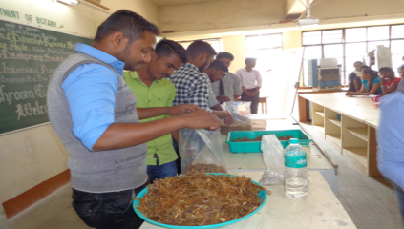 | Certificates issued to the students Participants

Add on Certificate Course in Training and processing of wild forest plants:
The Activity was sanctioned by Integrated Tribal Development Center, Rajur, Akole for the tribal students of College (2019-2020). Sanctioned Amount: Rupees 4,50,000/- (Four lacks fifty thousand only). Main focus was given on practical's of processing on wild forest plants : Amla Candy, Amla Syrup, Pickles, Amla Supari Medicinal formulations (Triphala Churna, Medicated Oils and Herbal Tea). As per the norms of project training was given to Scheduled tribes students of science faculty of our college only for the academic year -2019-2020. Here after we continued the course for next academic year 2020-2021 for students of all categories.
Inauguration of Course
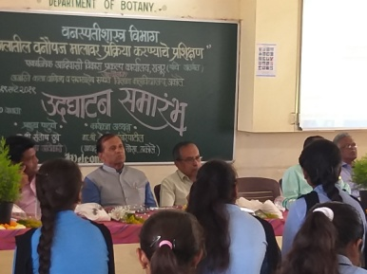
Photographs of Add on Certificate Course in Training and processing of wild forest plants
Chief Guest Hon. J.D. Ambre Patil,  Shri. M.D. Sonawane, Mr. B,K. Bhangare on the dice  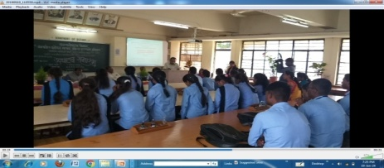 | Amla Supari Preparation  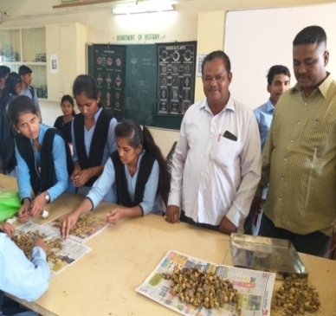
Shri. M.D. Sonawane addressing  the students  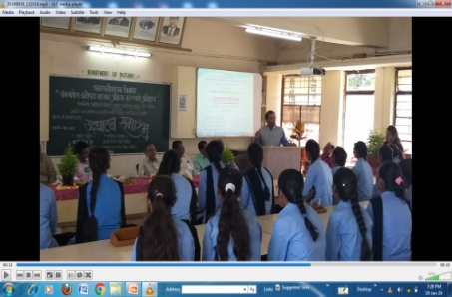 | Amla Candy Preparation

Herbarium Preparation by the Students of Botany

Dr. R.K. Waghmare Giving Training of Herbarium to the students of Botany
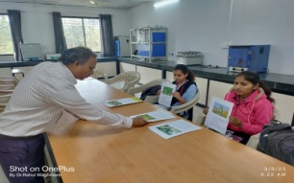

Mr. Jadhav and T.Y.B.Sc. Botany Students
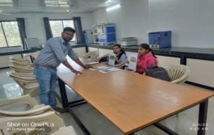

Mr.Karpe and T.Y.B.Sc. Botany Students
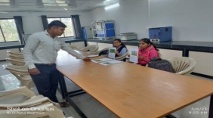

Mr. Jadhav Asst, Prof. giving information of Herbarium Preparation
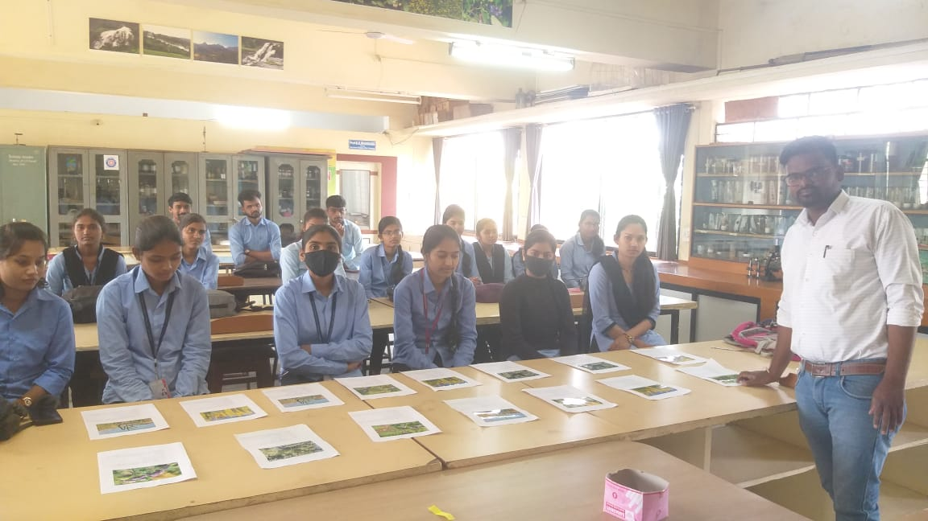

Students Demonstration the Herbarium Sheets

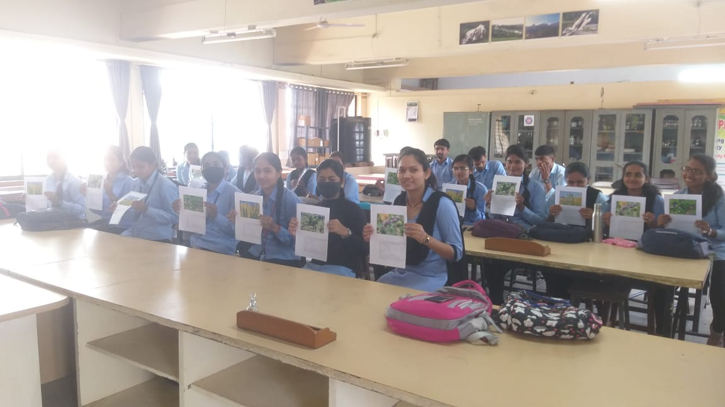

Herbarium Sheets Prepared by the Botany Students
Tree Plantation by students in Botanic Garden of College Preparation of Saplings of Plants
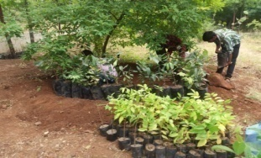

Sorting of Saplings of Plants
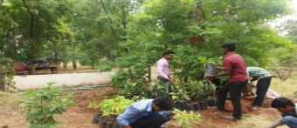
Field Preparation for Plantation
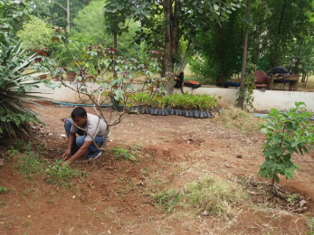

Implementation of Tanishka
The Tanishka activity was conducted for only F.Y.B.Sc. Girls students.The idea was to implement above objective-other than regular teaching.

Flower arrangements Preparations

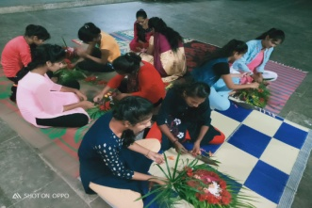
Bouquets Prepared by Girls Students
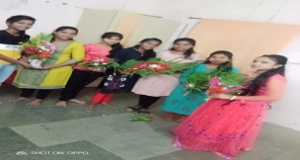

Yoga Performed by Girls Students
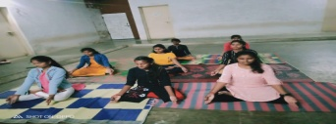

Student Centric Activity of Research : ‘AVISHKAR
Students Participating in Teachers Day Celebration in the Botany Laboratory
