साहसे श्री: प्रतिवसति |  
Akole Taluka Education Society,

**Agasti Arts, Commerce and Dadasaheb Rupwate Science College, Akole**

Tal – Akole, Dist – Ahmednagar. MH 422601

**Department of Economics**

**Arrange by Department**

**Level - State Level Seminar**

**Topic - Agriculture Problems and Prospects in Maharashtra**

**Sponsored by - Savitribai Phule Pune University, Pune**

Brochure

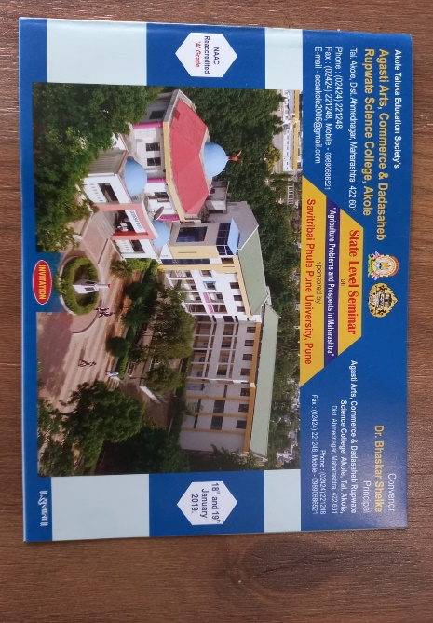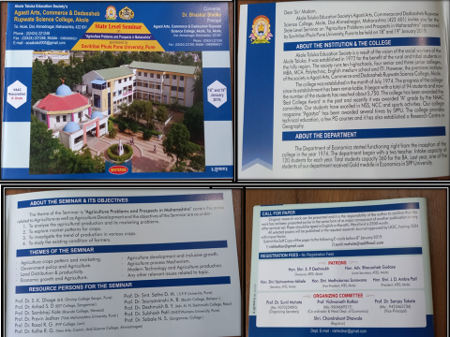

**Seminar Journals**

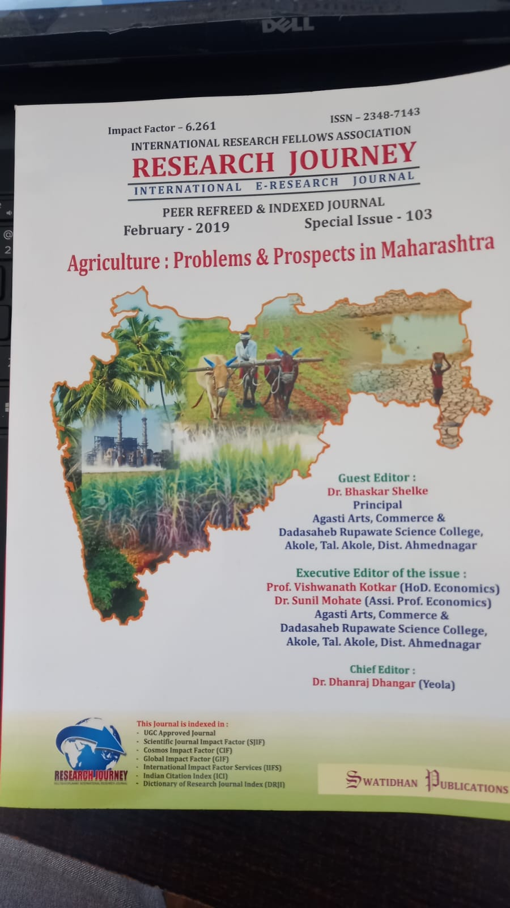

**Attended Seminars, Workshops, Conferences, etc.**

|  |  |  |  |  |  |
| --- | --- | --- | --- | --- | --- |
| **Sr.No.** | **Name of theTeacher** | **International** | **National** | **State** | **Total** |
| 1 | Dr. Vishwanath Kotkar | 00 | 03 | 02 | **05** |
| 2 | Dr. Sunil Mohate | 01 | 01 | 02 | **04** |
| **Total** | | **01** | **04** | **04** | **09** |

**Dr. Vishwanath Kotkar**

|  |  |  |  |
| --- | --- | --- | --- |
| **Sr. No** | **Level** | **Paper Title Month & Year** | **Publisher** |
| 1 | National  Level | Role of Agriculture in the Indian Economy (February 2018) | Printing Are |
| 2 | National  Level | भारतीय व्यापारी बँक आणि आव्हाने (January 2019) | Research Journey |
| 3 | National  Level | भारतीय बँकिंग क्षेत्राच्या समस्या आणि उपाय (January 2019) | Research Journey |
| 4 | State  Level | 2001 नंतरची महाराष्ट्रातील पिक पद्धती (February 2019) | Research Journey |
| 5 | State  Level | इलेक्ट्रॉनिक बँकिंग (March 2019) | Ajanta |

**Dr. Sunil Mohate**

|  |  |  |  |
| --- | --- | --- | --- |
| **Sr. No** | **Level** | **Paper Title Month & Year** | **Publisher** |
| 1 | International Level | भारतीय कृषी क्षेत्रासमोरील आव्हाने (Oc. 2017) | Scholarly Research Journal |
| 2 | National Level | निश्चीलीकरण आणि त्याचे परिणाम (January 2019) | Research Journey |
| 3 | State Level | वस्तू व सेवा कर पद्धतीचे फायदे  (January 2018) | Shodhankan |
| 4 | State Level | महाराष्ट्रातील शेतीसिंचन समस्या (February 2019) | Research Journey |